**Managing a GKE Multi-tenant Cluster with Namespaces**

experimentLabschedule1 hour 15 minutesuniversal_currency_alt5 Creditsshow_chartIntermediate

Rate Lab

**GSP766**



**Overview**

When considering cost optimization solutions for any Google Cloud infrastructure built around Google Kubernetes Engine (GKE) clusters, it's important to ensure that you're making effective use of the resources that are being billed. A common misstep is assigning a one to one ratio of users or teams to clusters, resulting in cluster proliferation.

A **multi-tenancy cluster** allows for multiple users or teams to share one cluster for their workloads while maintaining isolation and fair resource sharing. This is achieved by creating **namespaces**. Namespaces allow multiple virtual clusters to exist on the same physical cluster.

In this lab you will learn how to set up a multi-tenant cluster using multiple namespaces to optimize resource utilization and, in effect, optimize costs.

**Objectives**

In this lab, you will learn how to:

* Create multiple namespaces in a GKE cluster.
* Configure role-based access control for namespace access.
* Configure Kubernetes resource quotas for fair sharing resources across multiple namespaces.
* View and configure monitoring dashboards to view resource usage by namespace.
* Generate a GKE metering report in Looker Studio for fine grained metrics on resource utilization by namespace.

**Setup and requirements**

Before you click the Start Lab button

Read these instructions. Labs are timed and you cannot pause them. The timer, which starts when you click **Start Lab**, shows how long Google Cloud resources will be made available to you.

This hands-on lab lets you do the lab activities yourself in a real cloud environment, not in a simulation or demo environment. It does so by giving you new, temporary credentials that you use to sign in and access Google Cloud for the duration of the lab.

To complete this lab, you need:

* Access to a standard internet browser (Chrome browser recommended).

**Note:** Use an Incognito or private browser window to run this lab. This prevents any conflicts between your personal account and the Student account, which may cause extra charges incurred to your personal account.

* Time to complete the lab---remember, once you start, you cannot pause a lab.

**Note:** If you already have your own personal Google Cloud account or project, do not use it for this lab to avoid extra charges to your account.

How to start your lab and sign in to the Google Cloud console

1. Click the **Start Lab** button. If you need to pay for the lab, a pop-up opens for you to select your payment method. On the left is the **Lab Details** panel with the following:
   * The **Open Google Cloud console** button
   * Time remaining
   * The temporary credentials that you must use for this lab
   * Other information, if needed, to step through this lab
2. Click **Open Google Cloud console** (or right-click and select **Open Link in Incognito Window** if you are running the Chrome browser).

The lab spins up resources, and then opens another tab that shows the **Sign in** page.

***Tip:*** Arrange the tabs in separate windows, side-by-side.

**Note:**If you see the **Choose an account** dialog, click **Use Another Account**.

1. If necessary, copy the **Username** below and paste it into the **Sign in** dialog.

student-00-83670a407ee6@qwiklabs.net

Copied!

content_copy

You can also find the **Username** in the **Lab Details** panel.

1. Click **Next**.
2. Copy the **Password** below and paste it into the **Welcome** dialog.

sZPXktoQnS1p

Copied!

content_copy

You can also find the **Password** in the **Lab Details** panel.

1. Click **Next**.

**Important:**You must use the credentials the lab provides you. Do not use your Google Cloud account credentials.**Note:**Using your own Google Cloud account for this lab may incur extra charges.

1. Click through the subsequent pages:
   * Accept the terms and conditions.
   * Do not add recovery options or two-factor authentication (because this is a temporary account).
   * Do not sign up for free trials.

After a few moments, the Google Cloud console opens in this tab.

**Note:** To view a menu with a list of Google Cloud products and services, click the **Navigation menu** at the top-left. 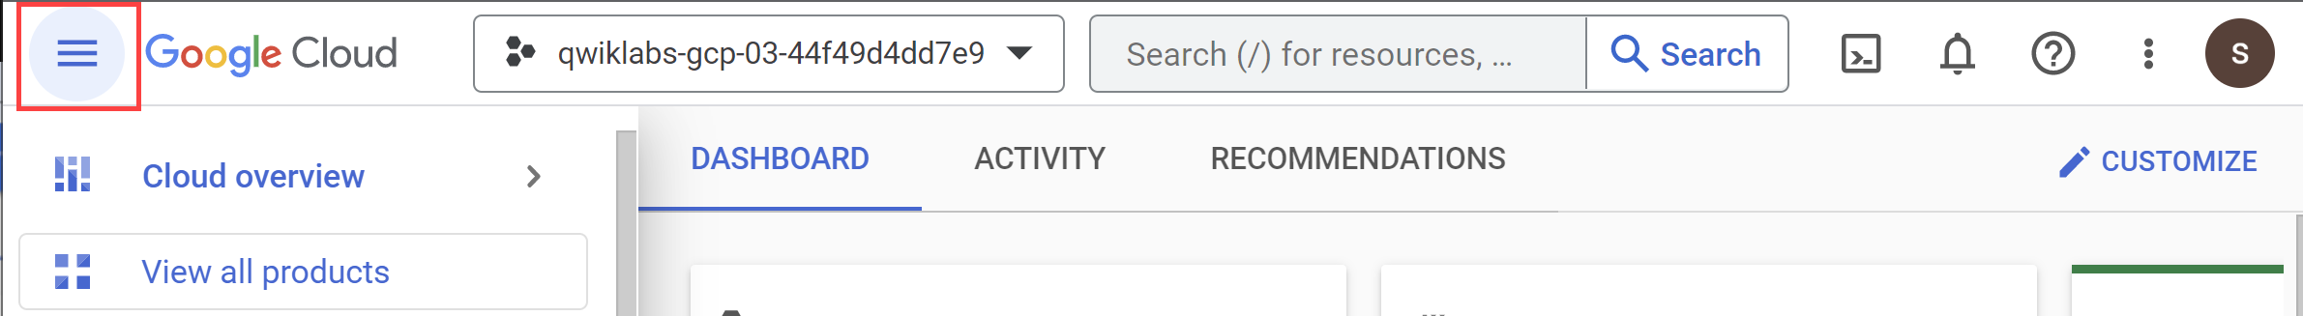

Start Up

After pressing the **Start Lab** button, you will see a blue Provisioning Lab Resources message with an estimated time remaining. It is creating and configuring the environment you will use to test managing a multi-tenant cluster. in about 5 minutes a cluster is created, BigQuery datasets are copied, and service accounts which will represent teams are generated.

Once finished, the message will no longer be displayed.

Please wait for this start up process to complete and the message to be removed before proceeding with the lab.

Activate Cloud Shell

Cloud Shell is a virtual machine that is loaded with development tools. It offers a persistent 5GB home directory and runs on the Google Cloud. Cloud Shell provides command-line access to your Google Cloud resources.

1. Click **Activate Cloud Shell** Activate Cloud Shell icon at the top of the Google Cloud console.

When you are connected, you are already authenticated, and the project is set to your **Project_ID**, qwiklabs-gcp-02-408de619aa1d. The output contains a line that declares the **Project_ID** for this session:

Your Cloud Platform project in this session is set to qwiklabs-gcp-02-408de619aa1d

gcloud is the command-line tool for Google Cloud. It comes pre-installed on Cloud Shell and supports tab-completion.

1. (Optional) You can list the active account name with this command:

gcloud auth list

Copied!

content_copy

1. Click **Authorize**.

**Output:**

ACTIVE: *

ACCOUNT: student-00-83670a407ee6@qwiklabs.net

To set the active account, run:

$ gcloud config set account `ACCOUNT`

1. (Optional) You can list the project ID with this command:

gcloud config list project

Copied!

content_copy

**Output:**

[core]

project = qwiklabs-gcp-02-408de619aa1d

**Note:**For full documentation of gcloud, in Google Cloud, refer to [the gcloud CLI overview guide](https://cloud.google.com/sdk/gcloud).

**Task 1. Download required files**

1. In this lab, some steps will use yaml files to configure your Kubernetes cluster. In your Cloud Shell, download these files from a Cloud Storage bucket:

gsutil -m cp -r gs://spls/gsp766/gke-qwiklab ~

Copied!

content_copy

1. Change your current working directory to gke-qwiklab:

cd ~/gke-qwiklab

Copied!

content_copy

**Task 2. View and create namespaces**

* Run the following to set a default compute zone and authenticate the provided cluster multi-tenant-cluster:

export ZONE=us-east4-c

gcloud config set compute/zone ${ZONE} && gcloud container clusters get-credentials multi-tenant-cluster

Copied!

content_copy

Default namespaces

By default, Kubernetes clusters have 4 system namespaces.

1. You can get a full list of the current cluster's namespaces with:

kubectl get namespace

Copied!

content_copy

The output should be similar to:

NAME STATUS AGE

default Active 5m

kube-node-lease Active 5m

kube-public Active 5m

kube-system Active 5m

* **default** - the default namespace used when no other namespace is specified
* **kube-node-lease** - manages the lease objects associated with the heartbeats of each of the cluster's nodes
* **kube-public** - to be used for resources that may need to be visible or readable by all users throughout the whole cluster
* **kube-system** - used for components created by the Kubernetes system

Not everything belongs to a namespace. For example, nodes, persistent volumes, and namespaces themselves do not belong to a namespace.

1. For a complete list of namespaced resources:

kubectl api-resources --namespaced=true

Copied!

content_copy

When they are created, namespaced resources must be associated with a namespace. This is done by including the --namespace flag or indicating a namespace in the yaml's metadata field.

1. The namespace can also be specified with any kubectl get subcommand to display a namespace's resources. For example:

kubectl get services --namespace=kube-system

Copied!

content_copy

This will output all services in the kube-system namespace.

Creating new namespaces

**Note:** When creating additional namespaces, avoid prefixing the names with ‘kube' as this is reserved for system namespaces.

1. Create 2 namespaces for team-a and team-b:

kubectl create namespace team-a && \

kubectl create namespace team-b

Copied!

content_copy

The output for kubectl get namespace should now include your 2 new namespaces:

namespace/team-a created

namespace/team-b created

By specifying the --namespace tag, you can create cluster resources in the provided namespace. Names for resources, such as deployments or pods, only need to be unique within their respective namespaces.

1. As an example, run the following to deploy a pod in the team-a namespace and in the team-b namespace using the same name:

kubectl run app-server --image=centos --namespace=team-a -- sleep infinity && \

kubectl run app-server --image=centos --namespace=team-b -- sleep infinity

Copied!

content_copy

1. Use kubectl get pods -A to see there are 2 pods named app-server, one for each team namespace:

kubectl get pods -A

Copied!

content_copy

Output:

NAMESPACE NAME READY STATUS RESTARTS AGE

kube-system event-exporter-gke-8489df9489-k2blq 2/2 Running 0 3m41s

kube-system fluentd-gke-fmt4v 2/2 Running 0 113s

kube-system fluentd-gke-n9dvn 2/2 Running 0 79s

kube-system fluentd-gke-scaler-cd4d654d7-xj78p 1/1 Running 0 3m37s

kube-system gke-metrics-agent-4jvn8 1/1 Running 0 3m33s

kube-system gke-metrics-agent-b4vvw 1/1 Running 0 3m27s

kube-system kube-dns-7c976ddbdb-gtrct 4/4 Running 0 3m41s

kube-system kube-dns-7c976ddbdb-k9bgk 4/4 Running 0 3m

kube-system kube-dns-autoscaler-645f7d66cf-jwqh5 1/1 Running 0 3m36s

kube-system kube-proxy-gke-new-cluster-default-pool-eb9986d5-tpql 1/1 Running 0 3m26s

kube-system kube-proxy-gke-new-cluster-default-pool-eb9986d5-znm6 1/1 Running 0 3m33s

kube-system l7-default-backend-678889f899-xvt5t 1/1 Running 0 3m41s

kube-system metrics-server-v0.3.6-64655c969-jtl57 2/2 Running 0 3m

kube-system prometheus-to-sd-d6dpf 1/1 Running 0 3m27s

kube-system prometheus-to-sd-rfdlv 1/1 Running 0 3m33s

kube-system stackdriver-metadata-agent-cluster-level-79f9ddf6d6-7ck2w 2/2 Running 0 2m56s

team-a app-server 1/1 Running 0 33s

team-b app-server 1/1 Running 0 33s

Click **Check my progress** to verify that you've performed the above task.

Assessment Completed!

Create namespaces

Check my progress

*Assessment Completed!*

1. Use kubectl describe to see additional details for each of the newly created pods by specifying the namespace with the --namespace tag:

kubectl describe pod app-server --namespace=team-a

Copied!

content_copy

1. To work exclusively with resources in one namespace, you can set it once in the kubectl context instead of using the --namespace flag for every command:

kubectl config set-context --current --namespace=team-a

Copied!

content_copy

1. After this, any subsequent commands will be run against the indicated namespace without specifying the --namespace flag:

kubectl describe pod app-server

Copied!

content_copy

In the next section, you will configure role-based access control for your namespaces to help organize the cluster.

**Task 3. Access Control in namespaces**

Provisioning access to namespaced resources in a cluster is accomplished by granting a combination of IAM roles and Kubernetes' built-in role-based access control (RBAC). An IAM role will give an account initial access to the project while the RBAC permissions will grant granular access to a cluster's namespaced resources (pods, deployments, services, etc).

IAM Roles

**Note:**To grant IAM roles in a project, you'll need the Project IAM Admin role assigned. This is already set up in your Qwiklabs temporary account.

When managing access control for Kubernetes, Identity and Access Management (IAM) is used to manage access and permissions on a higher organization and project levels.

There are several roles that can be assigned to users and service accounts in IAM that govern their level of access with GKE. RBAC's granular permissions build on the access already provided by IAM and cannot restrict access granted by it. As a result, for multi-tenant namespaced clusters, the assigned IAM role should grant minimal access.

Here's a table of common GKE IAM roles you can assign:

|  |  |
| --- | --- |
| **Role** | **Description** |
| **Kubernetes Engine Admin** | Provides access to full management of clusters and their Kubernetes API objects. A user with this role will be able to create, edit and delete any resource in **any** cluster and subsequent namespaces. |
| **Kubernetes Engine Developer** | Provides access to Kubernetes API objects inside clusters. A user with this role will be able to create, edit, and delete resources in **any** cluster and subsequent namespaces. |
| **Kubernetes Engine Cluster Admin** | Provides access to management of clusters. A user with this role will not have access to create or edit resources within any cluster or subsequent namespaces directly, but will be able to create, modify, and delete any cluster. |
| **Kubernetes Engine Viewer** | Provides read-only access to GKE resources. A user with this role will have read-only access to namespaces and their resources. |
| **Kubernetes Engine Cluster Viewer** | Get and list access to GKE Clusters. This is the minimal role required for anyone who needs to access resources within a cluster's namespaces. |

While most of these roles grant too much access to restrict with RBAC, the IAM role **Kubernetes Engine Cluster Viewer** gives users just enough permissions to access the cluster and namespaced resources.

Your lab project has a service account that will represent a developer that will use the team-a namespace.

* Grant the account the Kubernetes Engine Cluster Viewer role by running the following:

gcloud projects add-iam-policy-binding ${GOOGLE_CLOUD_PROJECT} \

--member=serviceAccount:team-a-dev@${GOOGLE_CLOUD_PROJECT}.iam.gserviceaccount.com \

--role=roles/container.clusterViewer

Copied!

content_copy

Kubernetes RBAC

Within a cluster, access to any resource type (pods, services, deployments, etc) is defined by either a **role** or a **cluster role**. Only **roles** are allowed to be scoped to a namespace. While a role will indicate the resources and the action allowed for each resource, a **role binding** will indicate to what user accounts or groups to assign that access to.

To create a role in the current namespace, specify the resource type as well as the ***verbs*** that will indicate what type of action that will be allowed.

1. Roles with single rules can be created with kubectl create:

kubectl create role pod-reader \

--resource=pods --verb=watch --verb=get --verb=list

Copied!

content_copy

Roles with multiple rules can be created using a yaml file. An example file is provided within the files you downloaded earlier in the lab.

1. Inspect the yaml file:

cat developer-role.yaml

Copied!

content_copy

Sample output:

apiVersion: rbac.authorization.k8s.io/v1

kind: Role

metadata:

namespace: team-a

name: developer

rules:

- apiGroups: [""]

resources: ["pods", "services", "serviceaccounts"]

verbs: ["update", "create", "delete", "get", "watch", "list"]

- apiGroups:["apps"]

resources: ["deployments"]

verbs: ["update", "create", "delete", "get", "watch", "list"]

1. Apply the role above:

kubectl create -f developer-role.yaml

Copied!

content_copy

1. Create a role binding between the team-a-developers serviceaccount and the developer-role:

kubectl create rolebinding team-a-developers \

--role=developer --user=team-a-dev@${GOOGLE_CLOUD_PROJECT}.iam.gserviceaccount.com

Copied!

content_copy

Test the rolebinding

1. Download the service account keys used to impersonate the service account:

gcloud iam service-accounts keys create /tmp/key.json --iam-account team-a-dev@${GOOGLE_CLOUD_PROJECT}.iam.gserviceaccount.com

Copied!

content_copy

Click **Check my progress** to verify that you've performed the above task.

Assessment Completed!

Access Control in namespaces

Check my progress

*Assessment Completed!*

1. In Cloud Shell click the + to open a new tab in your terminal.
2. Here, run the following to activate the service account. This will allow you to run the commands as the account:

gcloud auth activate-service-account --key-file=/tmp/key.json

Copied!

content_copy

1. Get the credentials for your cluster, as the service account:

export ZONE=us-east4-c

gcloud container clusters get-credentials multi-tenant-cluster --zone ${ZONE} --project ${GOOGLE_CLOUD_PROJECT}

Copied!

content_copy

1. You'll see now that as team-a-dev you're able to list pods in the team-a namespace:

kubectl get pods --namespace=team-a

Copied!

content_copy

Output:

NAME READY STATUS RESTARTS AGE

app-server 1/1 Running 0 6d

1. But listing pods in the team-b namespace is restricted:

kubectl get pods --namespace=team-b

Copied!

content_copy

Output:

Error from server (Forbidden): pods is forbidden: User "team-a-dev@a-gke-project.iam.gserviceaccount.com" cannot list resource "pods" in API group "" in the namespace "team-b": requires one of ["container.pods.list"] permission(s).

1. Return to your first Cloud Shell tab or open a new one.
2. Renew the cluster credentials and reset your context to the team-a namespace:

export ZONE=us-east4-c

gcloud container clusters get-credentials multi-tenant-cluster --zone ${ZONE} --project ${GOOGLE_CLOUD_PROJECT}

Copied!

content_copy

**Task 4. Resource quotas**

When a cluster is shared in a multi-tenant set up, it's important to make sure that users are not able to use more than their fair share of the cluster resources. A resource quota object (ResourceQuota) will define constraints that will limit resource consumption in a namespace. A resource quota can specify a limit to object counts (pods, services, stateful sets, etc), total sum of storage resources (persistent volume claims, ephemeral storage, storage classes ), or total sum of compute resources. (cpu and memory).

1. For example, the following will set a limit to the number of pods allowed in the namespace team-a to 2, and the number of loadbalancers to 1:

kubectl create quota test-quota \

--hard=count/pods=2,count/services.loadbalancers=1 --namespace=team-a

Copied!

content_copy

1. Create a second pod in the namespace team-a:

kubectl run app-server-2 --image=centos --namespace=team-a -- sleep infinity

Copied!

content_copy

1. Now try to create a third pod:

kubectl run app-server-3 --image=centos --namespace=team-a -- sleep infinity

Copied!

content_copy

You should receive the following error:

Error from server (Forbidden): pods "app-server-3" is forbidden: exceeded quota: test-quota, requested: count/pods=1, used: count/pods=2, limited: count/pods=2

1. You can check details about your resource quota using kubectl describe:

kubectl describe quota test-quota --namespace=team-a

Copied!

content_copy

Output:

Name: test-quota

Namespace: team-a

Resource Used Hard

-------- ---- ----

count/pods 2 2

count/services.loadbalancers 0 1

Here you can see a list of resources restricted by the resource quota, along with the hard limit configured and the quantity currently used.

1. Update test-quota to have a limit of 6 pods by running:

export KUBE_EDITOR="nano"

kubectl edit quota test-quota --namespace=team-a

Copied!

content_copy

You'll be able to edit a yaml file that kubectl will use to update the quota. The hard quota is the value for count/pods under spec.

1. Change the value of count/pods under spec to **6**:

apiVersion: v1

kind: ResourceQuota

metadata:

creationTimestamp: "2020-10-21T14:12:07Z"

name: test-quota

namespace: team-a

resourceVersion: "5325601"

selfLink: /api/v1/namespaces/team-a/resourcequotas/test-quota

uid: a4766300-29c4-4433-ba24-ad10ebda3e9c

spec:

hard:

count/pods: "6"

count/services.loadbalancers: "1"

status:

hard:

count/pods: "5"

count/services.loadbalancers: "1"

used:

count/pods: "2"

1. Press **ctrl + X**, **Y** and **Enter** to save and exit.

The updated quota should now be reflected in the output:

kubectl describe quota test-quota --namespace=team-a

Copied!

content_copy

Output:

Name: test-quota

Namespace: team-a

Resource Used Hard

-------- ---- ----

count/pods 2 6

count/services.loadbalancers 0 1

**CPU and memory quotas**

When setting quotas for CPU and memory, you can indicate a quota for the sum of requests (a value that a container is guaranteed to get) or the sum of limits (a value that a container will never be allowed to pass).

In this lab, your cluster has 4 e2-standard-2 machines, with 2 core and 8GB memory each. You have been provided with a sample resource quota yaml file for your cluster:

cpu-mem-quota.yaml

apiVersion: v1

kind: ResourceQuota

metadata:

name: cpu-mem-quota

namespace: team-a

spec:

hard:

limits.cpu: "4"

limits.memory: "12Gi"

requests.cpu: "2"

requests.memory: "8Gi"

1. Apply the file configuration:

**Note:**Make sure you're still in the **gke-qwiklab** directory.

kubectl create -f cpu-mem-quota.yaml

Copied!

content_copy

With this quota in place, the sum of all pods' CPU and memory requests will be capped at 2cpu and 8GiB, and their limits at 4cpu and 12GiB, respectively.

**Note:**When a resource quota for CPU or memory exists in a namespace, every container that is created in that namespace thereafter must have its own CPU and memory limit defined on creation or by having a default value assigned in the namespace as a LimitRange.

1. To demonstrate the CPU and memory quota, create a new pod using cpu-mem-demo-pod.yaml:

cpu-mem-demo-pod.yaml:

apiVersion: v1

kind: Pod

metadata:

name: cpu-mem-demo

namespace: team-a

spec:

containers:

- name: cpu-mem-demo-ctr

image: nginx

resources:

requests:

cpu: "100m"

memory: "128Mi"

limits:

cpu: "400m"

memory: "512Mi"

1. Apply the file configuration:

kubectl create -f cpu-mem-demo-pod.yaml --namespace=team-a

Copied!

content_copy

1. Once this pod has been created, run the following to see its CPU and memory requests and limits reflected in the quota:

kubectl describe quota cpu-mem-quota --namespace=team-a

Copied!

content_copy

Output:

Name: cpu-mem-quota

Namespace: team-a

Resource Used Hard

-------- ---- ----

limits.cpu 400m 4

limits.memory 512Mi 12Gi

requests.cpu 100m 2

requests.memory 128Mi 8Gi

Click **Check my progress** to verify that you've performed the above task.

Assessment Completed!

Resource quotas

Check my progress

*Assessment Completed!*

**Task 5. Monitoring GKE and GKE usage metering**

For most multi-tenant clusters, it's likely that the workloads and resource requirements of each of the tenants will change and resource quotas might need to be adjusted. By using Monitoring you can get a general view of the resources each namespace is using.

With GKE usage metering, you're able to get a more granular view of that resource usage and subsequently a better idea of costs associated with each tenant.

**Monitoring Dashboard**

1. In the Cloud Console, expand the **Navigation menu** at the top left corner of the page and then select **Operations** > **Monitoring** within that menu.

Wait a minute while your workspace for your project is constructed.

1. Once you're on the Overview page, select **Dashboards** from the left menu:

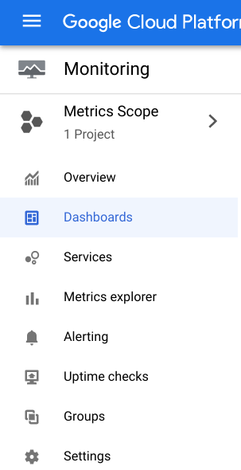

1. Select **GKE** from the *Dashboards Overview* page.

The GKE Dashboard presents you with a collection of tables detailing CPU, memory, and disk utilization aggregated by several resources.

For example, the Namespaces table will show you utilization for each of your clusters' namespaces:

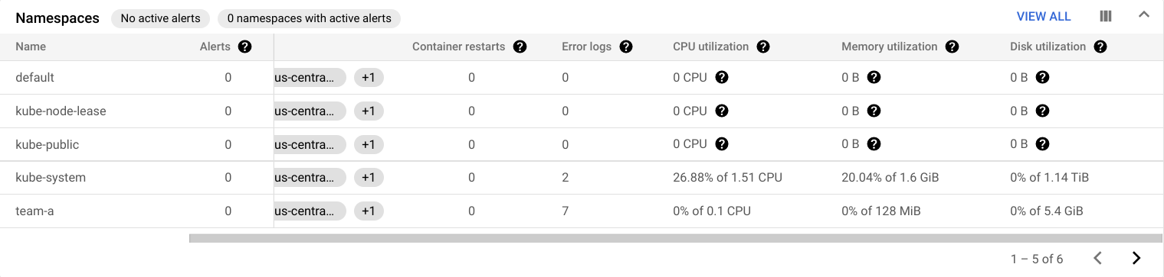

You can also get a look at the utilization data for the workloads running on your cluster in the Workloads table.

1. Click **View All**.
2. In the ADD FILTER box select **Namespaces** > **team-a**.
3. Then click **Apply**.

This will filter workloads to include only those running on the team-a namespace:

**Metrics Explorer**

1. From the left-side pane select **Metrics Explorer**.
2. In the Select a metric field, click on **Metric** dropdown.
3. Type **Kubernetes Container** in filter by resource and metric name.
4. Click on **Kubernetes Container > Container**.
5. Select CPU usage time.
6. Click **Apply**.

**Note:**Type **cp** into the metric field and you should see CPU usage time appear as an option in a dropdown menu.

1. To exclude the kube-system namespace, click **Add filter** in the filter section.
2. Select namespace_name as a Label.
3. Select != (does not equal) as the comparison and kube-system as the value.
4. Next, for the **Aggregation** dropdown select **Sum** and for by dropdown select **namespace_name** and click **OK**.

What you'll see is a graph showing container CPU usage time by namespace:

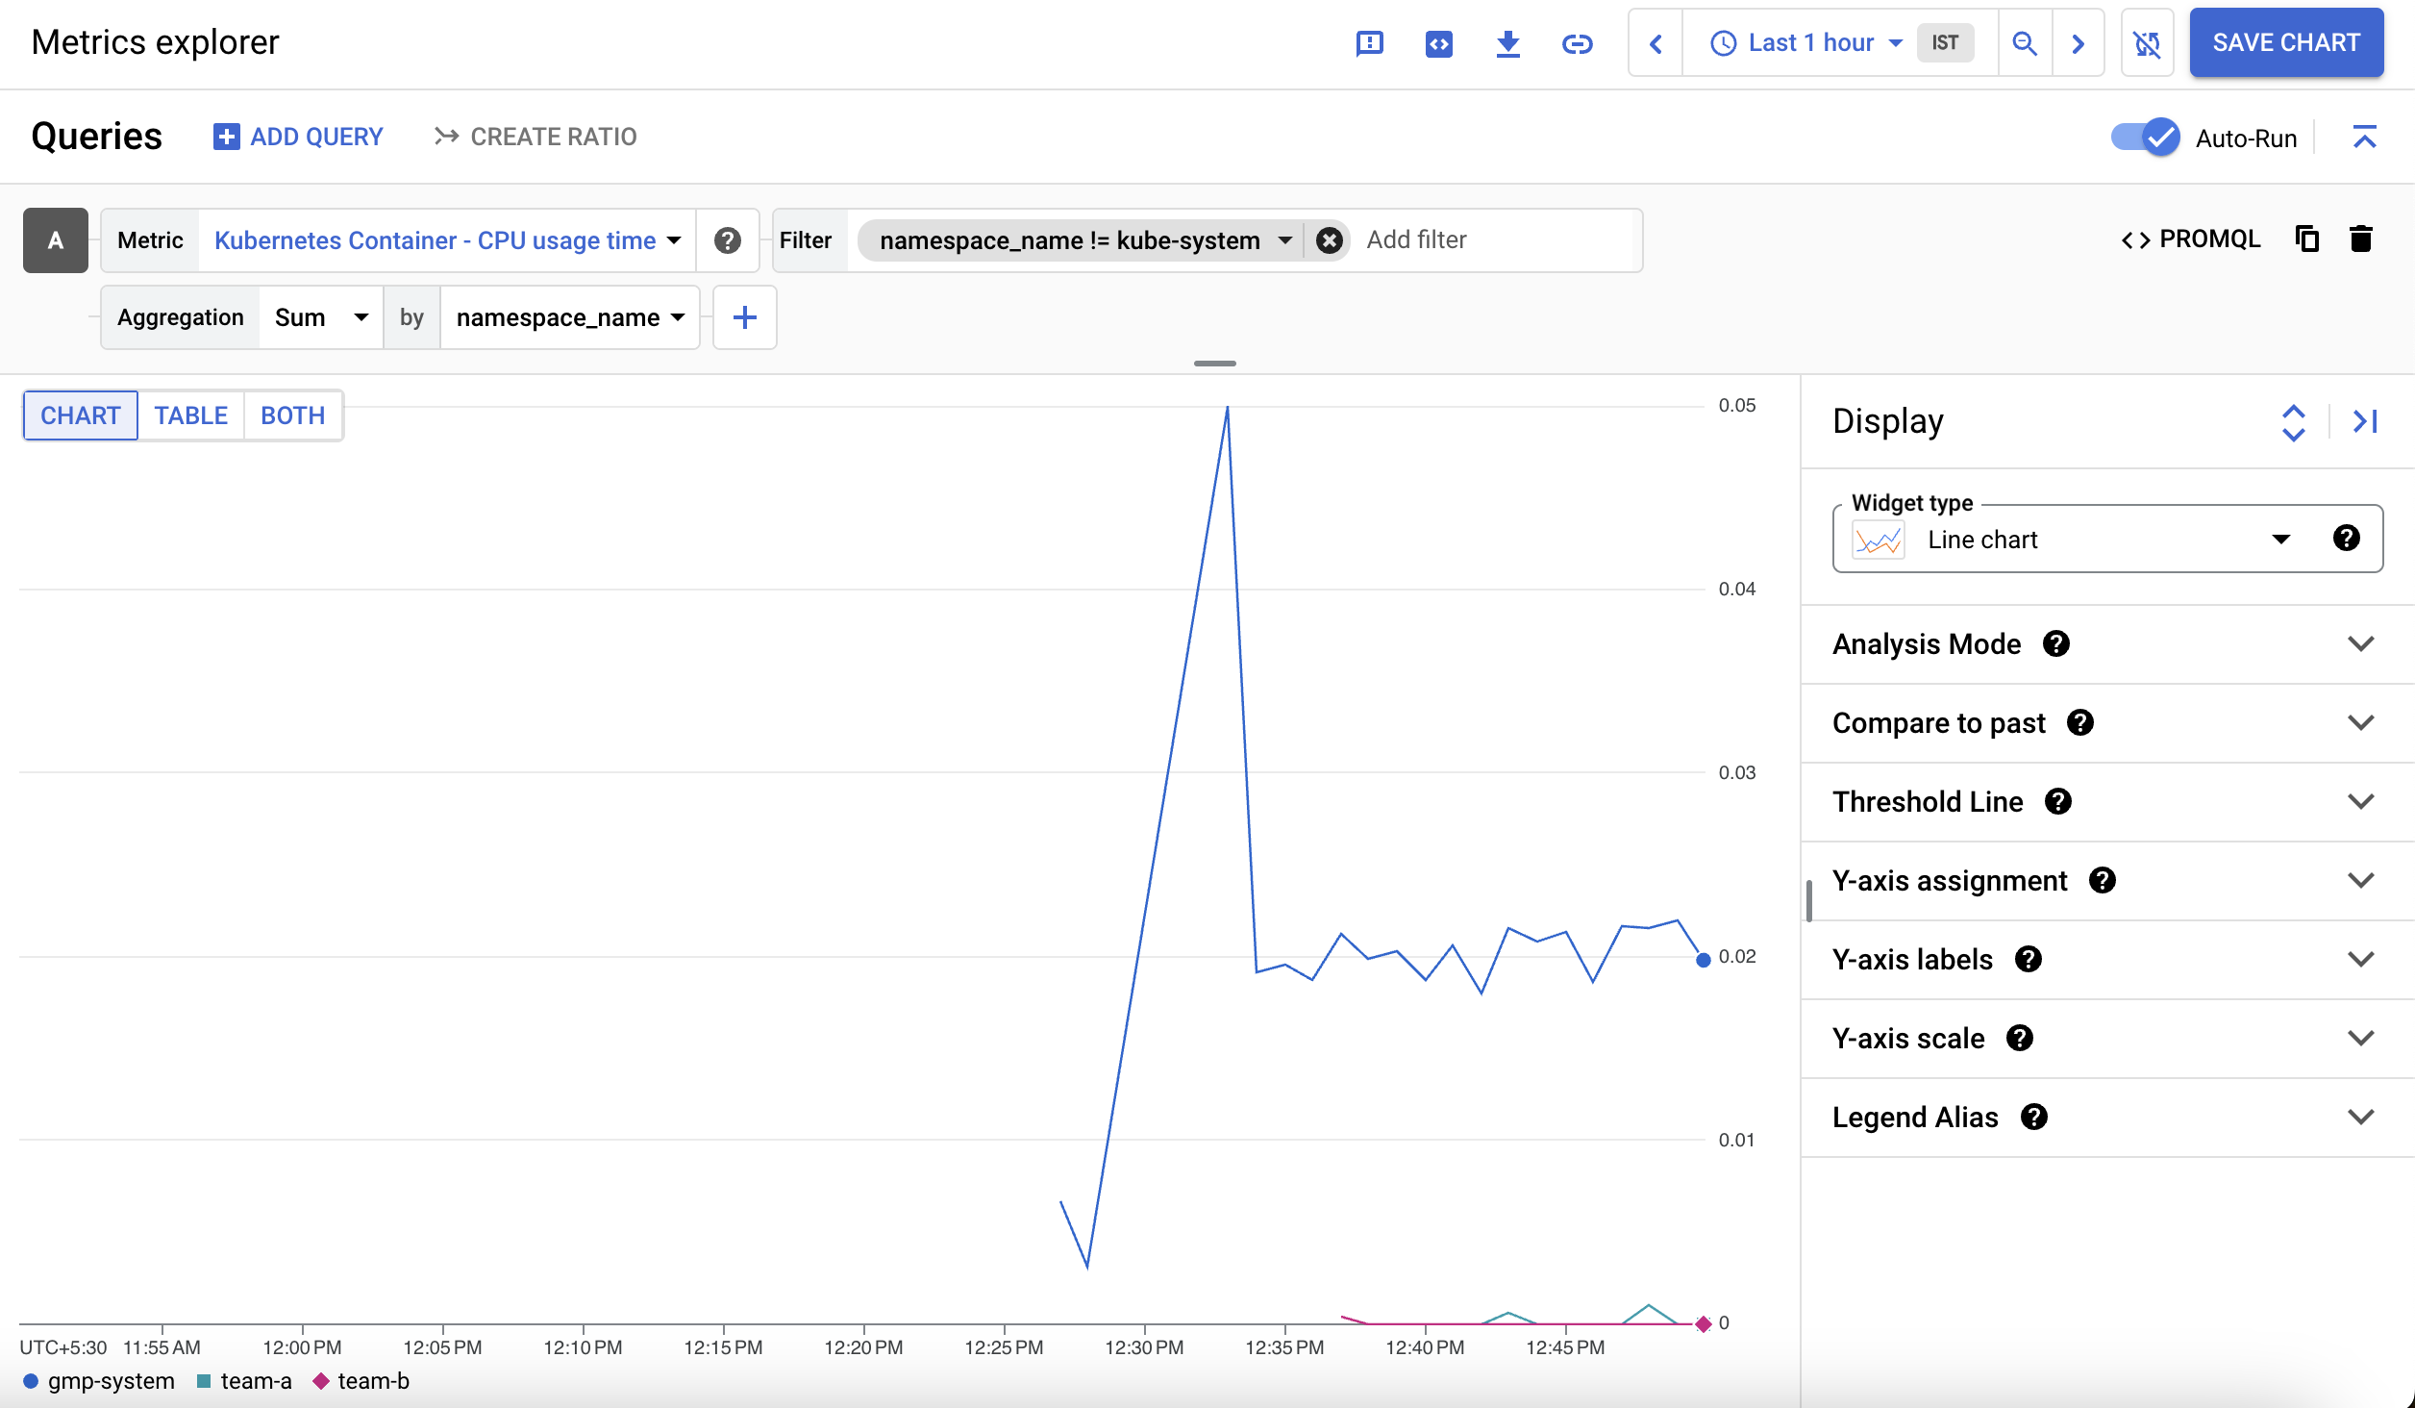

**GKE usage metering**

GKE usage metering allows you to export your GKE cluster resource utilization and consumption to a BigQuery dataset where you can visualize it using Looker Studio. It allows for a more granular view of resource usage. By using usage metering, you are able to make more informed decisions on resource quotas and efficient cluster configuration.

**Note:**Because it can take several hours for GKE metric data to populate BigQuery, your lab project includes BigQuery datasets with simulated resource usage and billing data for demonstrative purposes.

The following two datasets have been added to your project:

**cluster_dataset** - this is a dataset manually created before enabling GKE usage metering on the cluster. This dataset contains 2 tables generated by GKE (gke_cluster_resource_consumption and gke_cluster_resource_usage) and is continuously updated with cluster usage metrics.

**billing_dataset**- this is a dataset manually created before enabling BigQuery export for billing. This dataset contains 1 table (gcp_billing_export_v1_xxxx) and is updated each day with daily costs of a project.

* Run the following to enable GKE usage metering on the cluster and specify the dataset cluster_dataset:

export ZONE=us-east4-c

gcloud container clusters \

update multi-tenant-cluster --zone ${ZONE} \

--resource-usage-bigquery-dataset cluster_dataset

Copied!

content_copy

Create the GKE cost breakdown table

A cost_breakdown table can be generated from the billing and resource usage tables in your project. You'll generate this table in the cluster dataset using the file usage_metering_query_template.sql. This template is available through [Understanding cluster resource usage](https://cloud.google.com/kubernetes-engine/docs/how-to/cluster-usage-metering#create_the_cost_breakdown_table).

First, in Cloud Shell, set some environment variables.

1. Set the path of the provided billing table, the provided usage metering dataset, and a name for the new cost breakdown table:

export GCP_BILLING_EXPORT_TABLE_FULL_PATH=${GOOGLE_CLOUD_PROJECT}.billing_dataset.gcp_billing_export_v1_xxxx

export USAGE_METERING_DATASET_ID=cluster_dataset

export COST_BREAKDOWN_TABLE_ID=usage_metering_cost_breakdown

Copied!

content_copy

1. Next, specify the path of the usage metering query template downloaded at the start of this lab, an output file for the usage metering query that will be generated, and a start date for the data (the earliest date in the data is 2020-10-26):

export USAGE_METERING_QUERY_TEMPLATE=~/gke-qwiklab/usage_metering_query_template.sql

export USAGE_METERING_QUERY=cost_breakdown_query.sql

export USAGE_METERING_START_DATE=2020-10-26

Copied!

content_copy

1. Now, using these environment variables and the query template, generate the usage metering query:

sed \

-e "s/\${fullGCPBillingExportTableID}/$GCP_BILLING_EXPORT_TABLE_FULL_PATH/" \

-e "s/\${projectID}/$GOOGLE_CLOUD_PROJECT/" \

-e "s/\${datasetID}/$USAGE_METERING_DATASET_ID/" \

-e "s/\${startDate}/$USAGE_METERING_START_DATE/" \

"$USAGE_METERING_QUERY_TEMPLATE" \

> "$USAGE_METERING_QUERY"

Copied!

content_copy

1. Run the following command to set up your cost breakdown table using the query you rendered in the previous step:

bq query \

--project_id=$GOOGLE_CLOUD_PROJECT \

--use_legacy_sql=false \

--destination_table=$USAGE_METERING_DATASET_ID.$COST_BREAKDOWN_TABLE_ID \

--schedule='every 24 hours' \

--display_name="GKE Usage Metering Cost Breakdown Scheduled Query" \

--replace=true \

"$(cat $USAGE_METERING_QUERY)"

Copied!

content_copy

1. Data Transfer should provide a link for authorization. Click it, log in with your student account, follow the instructions, and paste the version_info back in your Cloud Shell.

Afterwards, this should return a message indicating that the transfer configuration has been successfully created.

Create the data source in Looker Studio

1. Open the [Looker Studio Data Sources page](https://lookerstudio.google.com/c/navigation/datasources).
2. On the top left click **Create** > **Data Source** to add a new data source.

You'll first be presented with the **To get started, let's complete your account setup** window.

1. Check the acknowledgement box and then click **Continue**.
2. Select **No** for each **Set up your email preferences**, as this is a temporary lab/account.
3. Click **Continue**.

You'll be presented with a list of Google Connectors that are supported by Looker Studio.

1. Select BigQuery from the list.

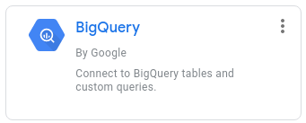

1. Click the **Authorize** button to allow Looker Studio to access your BigQuery project.
2. At the top left of the page, rename your data source from Untitled Data Source to GKE Usage.
3. From the first column, select **CUSTOM QUERY**.
4. Select your **project ID** from the projects column.
5. Enter the following query in the custom query box and replace [PROJECT-ID] with your Qwiklabs project id:

SELECT * FROM `[PROJECT-ID].cluster_dataset.usage_metering_cost_breakdown`

Copied!

content_copy

1. Click **CONNECT**.

Click **Check my progress** to verify that you've performed the above task.

Assessment Completed

Monitoring GKE and GKE usage metering

Check my progress

*Assessment Completed*

1. Next, click at the top right.

Now that the data source has been added, it's time to use it to create a report.

1. At the top of your data source page, click **CREATE REPORT**.

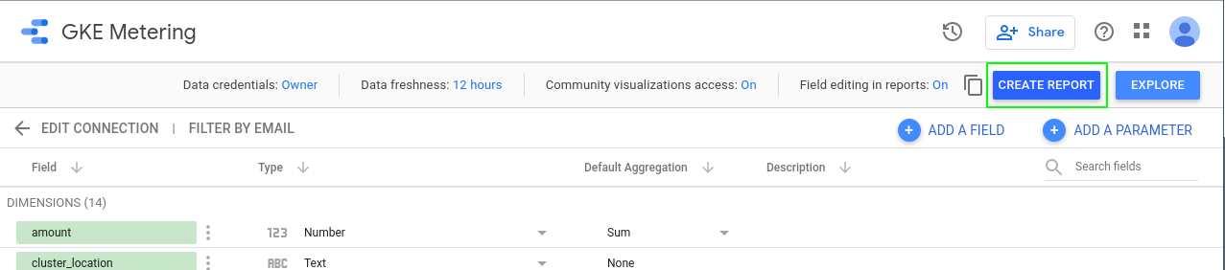

**Note:**If you get an error at this point, your Data Transfer job may not have completed yet. Wait a minute and try again.

When creating a new report from a data source, you'll be prompted to add data to your report.

1. Click **ADD TO REPORT**.

Create a Looker Studio Report

The report will be where you'll be able to visualize the usage metrics from the data source based on your BigQuery table.

You'll start out with a simple table:

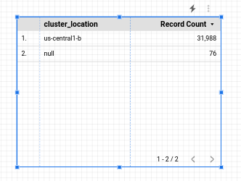

You'll configure this table to show a cost breakdown by namespace. With the table selected, you'll see data related to it on the panel to the right.

1. Change the following in that panel:

* **Data Range Dimension:** usage_start_time
* **Dimension:** namespace
* **Metric:** cost

Leave all other fields with their default values.

To limit your table to namespaced resources you can apply a filter.

1. In the data panel click **Add a Filter** under the Filter section. Create a filter that will exclude resources unallocated to a namespace:

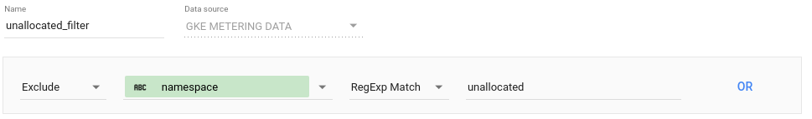

1. Click **Save**.
2. Click **Add a Filter** again and **Create a Filter** to create a second filter which will limit the data to requests:

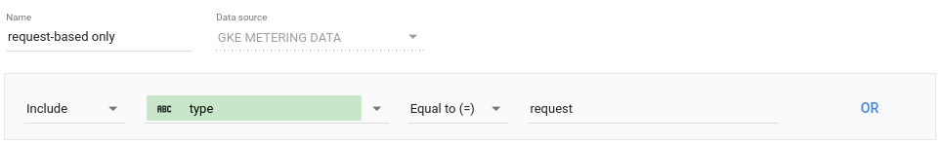

1. Click **Save** to apply the filter. The resulting table should look like this:

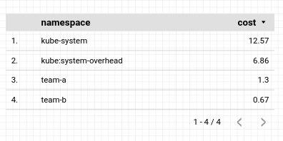

Next, you'll add a pie chart to your report that shows the cost breakdown by namespace.

1. Right click the table you created and select **Duplicate**.
2. Drag the duplicate table object anywhere on your report.
3. Next, click the header of the configuration panel:

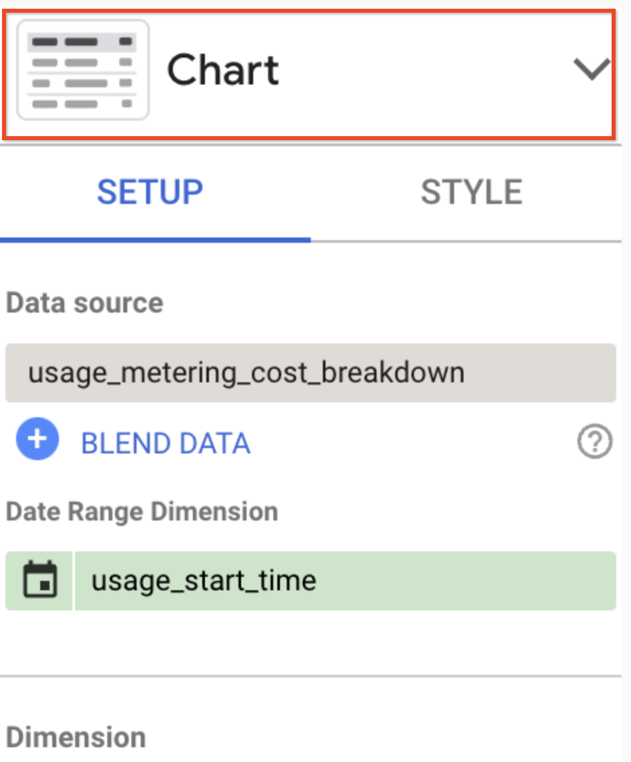

1. From the options presented, click the **pie chart** icon:

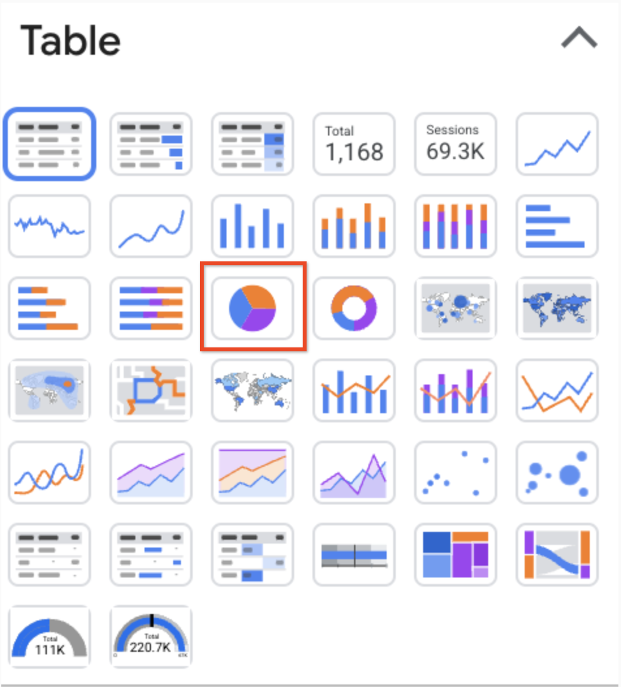

The resulting pie chart will look like this:

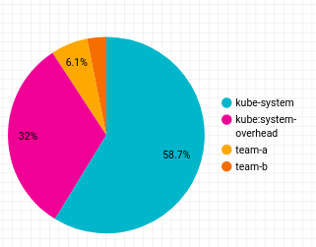

Next, you'll add a donut chart that will show the cost breakdown by resource type.

1. From the top toolbar click **Add a chart** and select 23497d0573f8232a.png (Donut) to create a donut chart.
2. Drag the chart anywhere on your report, and configure it with the following:

* **Data Range Dimension:** usage_start_time
* **Dimension:** resource_name
* **Metric:** cost

1. Click **Add a Filter** and select the 2 filters you applied to the previous chart. The resulting donut chart will look like this:

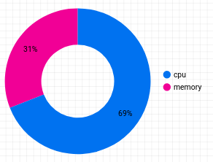

1. To add a breakdown by namespace, from the top toolbar click **Add a control** and select **Drop-down list**.
2. Drag it next to your donut chart and configure it with the following:

* **Data Range Dimension:** usage_start_time
* **Control field:** namespace
* **Metric:** None

1. Click **Add a filter**.
2. Select **unallocated (namespace filter)** from the list.
3. In order to configure the control to affect only the donut chart, select both the control object and the donut chart using the selector cursor to draw a rectangle around both objects.
4. Right click and select **Group** to bind them into a group:

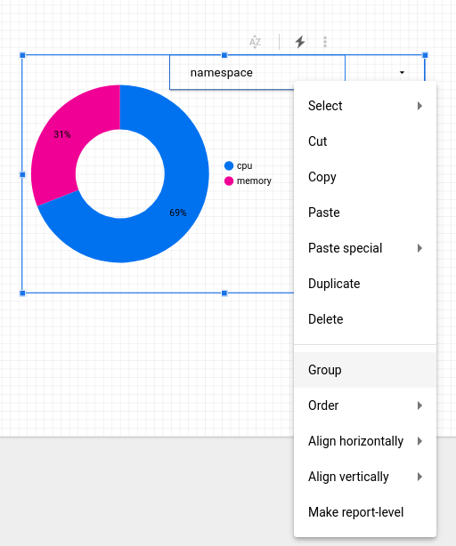

1. To preview your report, click **View** from the top toolbar.

In view mode, you'll be able to adjust the view of your donut chart to a particular namespace:

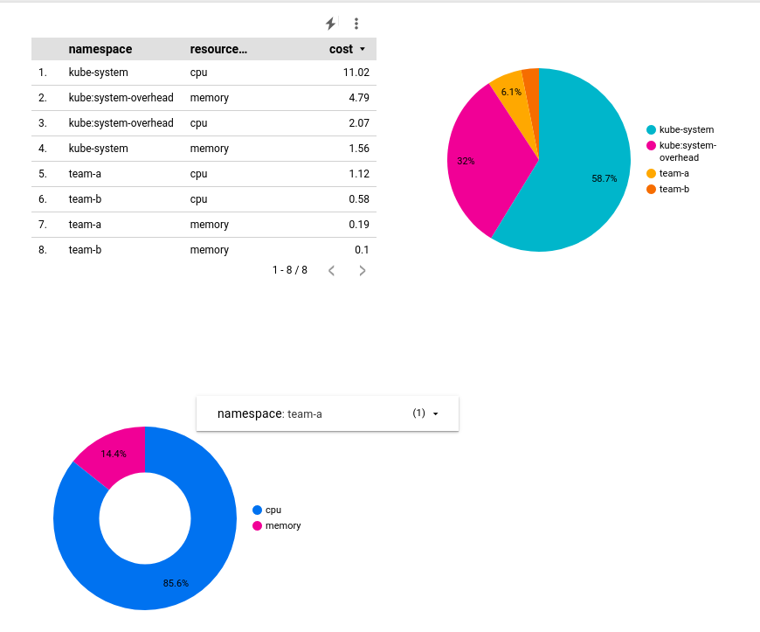

1. From the **Share** menu at the top of the page click **Download report** to download a copy of the full report as a PDF file.

**Congratulations!**

By utilizing namespaces, you're able to configure clusters as multi-tenant, minimizing risk of under utilization of resources and cluster proliferation, and avoiding incurring additional costs. By using monitoring and GKE metering, you're also able to visualize resource utilization by namespaces in order to make better informed decisions on resource quotas and cluster configuration.

Next steps / learn more

* [Cluster Multi-tenancy Docs](https://cloud.google.com/kubernetes-engine/docs/concepts/multitenancy-overview)
* [Best practices for running cost-optimized Kubernetes applications on GKE](https://cloud.google.com/solutions/best-practices-for-running-cost-effective-kubernetes-applications-on-gke)

Google Cloud training and certification

...helps you make the most of Google Cloud technologies. [Our classes](https://cloud.google.com/training/courses) include technical skills and best practices to help you get up to speed quickly and continue your learning journey. We offer fundamental to advanced level training, with on-demand, live, and virtual options to suit your busy schedule. [Certifications](https://cloud.google.com/certification/) help you validate and prove your skill and expertise in Google Cloud technologies.

**Manual Last Updated February 02, 2024**

**Lab Last Tested February 02, 2024**

Copyright 2024 Google LLC All rights reserved. Google and the Google logo are trademarks of Google LLC. All other company and product names may be trademarks of the respective companies with which they are associated.

[navigate_beforePrevious](https://www.cloudskillsboost.google/course_sessions/14779744/video/464668)[Nextnavigate_next](https://www.cloudskillsboost.google/course_sessions/14779744/video/464670)